| **Name :**  Dyotak Kachare | **Class/Roll No. :**  D11AD/26 | **Grade:** |
| --- | --- | --- |

**Title of Experiment :**

Construction of Cubes , OLAP Operations, OLAP Queries

**Objective of Experiment :**

To introduce the concept of data Mining as an important tool for enterprise data management and as a cutting edge technology for building competitive advantage

**Outcome of Experiment :**

Analyze data using OLAP operations so as to take strategic decisions.

**Problem Statement :**

Construction of Cubes , OLAP Operations, OLAP Queries

**Description / Theory :**

OLAP is a powerful graphics-oriented tool used to access the data warehouse

OLAP supports

* Business analysis queries
* Data visualization
* Trend analysis
* Scenario analysis
* User defined queries

Features of OLAP

* Enables executives , managers to gain useful insights from presentation of data
* Can reorganize metrics along several dimensions and allow data to be viewed from different perspectives
* Supports multidimensional analysis
* Supports drill down, roll up, etc
* Also visual presentation for result comprehension
* Can be implemented on the web
* Highly interactive analysis can be done

OLAP Cube

* A multidimensional structure that forms the basis for OLAP applications.
* A variety of cross-dimensional calculations and aggregations are possible within a cube.
* Despite the name, most OLAP cubes have more than three dimensions.
* Axes of the cube represent attributes of the data records
  + Generally discrete-valued / categorical
  + e.g. color, month, state
  + Called dimensions
* Cells hold aggregated measurements
  + e.g. total $ sales, number of autos sold
  + Called facts

OLAP Operation

Drill Down

* Navigate to higher levels of detail
* Example: from regional analysis to specific plant analysis, further to team analysis, ...

Roll Up

* Navigate to lower levels of detail
* Example: from month analysis to a quarter analysis

Slice

* Cut through the cube, so that users can focus on some specific perspectives
* Example: only analyzing on the product CellPhone

Dice

* Get one cell from the cube (the smallest slice)
* Example: get the production volume of Armonk, for CellPhone 1001, in January (here, we suppose plant, product model and month are the smallest members in Location, Product, Time dimensions respectively)

Pivot

* Rotate the cube
* Example: change the perspective from

**Code and Output :**

SELECT SUM(charge) AS ChargeSum, category

FROM spectator

GROUP BY CUBE(spectator.category);

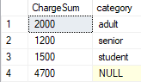

select sum(spec.charge) as ChargeSum, spec.category, g.game_id

from game_stat gs, game g, spectator spec, [location] l

where

gs.game_id = g.game_id and

gs.spec_id = spec.spec_id and

gs.loc_id = l.loc_id

group by cube (spec.category, g.game_id)

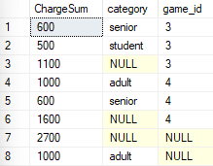

select sum(spec.charge) as ChargeSum, spec.category, g.game_id, l.stadium

from game_stat gs, game g, spectator spec, [location] l

where

gs.game_id = g.game_id and

gs.spec_id = spec.spec_id and

gs.loc_id = l.loc_id

group by cube (spec.category, g.game_id, l.stadium)

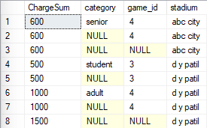

--ROLLUP

SELECT SUM(spec.charge) as ChargeSum, spec.category, g.game_id, l.stadium

FROM game_stat gs

JOIN game g ON gs.game_id = g.game_id

JOIN spectator spec ON gs.spec_id = spec.spec_id

JOIN location l ON gs.loc_id = l.loc_id

GROUP BY rollup(spec.category, g.game_id, l.stadium);

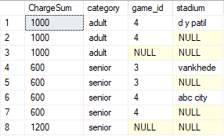

SELECT SUM(spec.charge) as ChargeSum, spec.category, g.game_name

FROM game_stat gs

JOIN game g ON gs.game_id = g.game_id

JOIN spectator spec ON gs.spec_id = spec.spec_id

GROUP BY rollup(spec.category, g.game_name);

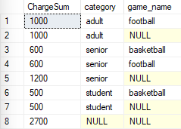

--slice

SELECT SUM(spec.charge) as ChargeSum, spec.category, g.game_id, l.stadium

FROM game_stat gs

JOIN game g ON gs.game_id = g.game_id

JOIN spectator spec ON gs.spec_id = spec.spec_id

JOIN location l ON gs.loc_id = l.loc_id

GROUP BY rollup(spec.category, g.game_id, l.stadium)

HAVING spec.category = 'student';

SELECT SUM(spec.charge) as ChargeSum, spec.category, g.game_id, l.stadium

FROM game_stat gs

JOIN game g ON gs.game_id = g.game_id

JOIN spectator spec ON gs.spec_id = spec.spec_id

JOIN location l ON gs.loc_id = l.loc_id

GROUP BY rollup(spec.category, g.game_id, l.stadium)

HAVING g.game_id = 3;

SELECT SUM(spec.charge) as ChargeSum, spec.category, g.game_id, l.stadium

FROM game_stat gs

JOIN game g ON gs.game_id = g.game_id

JOIN spectator spec ON gs.spec_id = spec.spec_id

JOIN location l ON gs.loc_id = l.loc_id

GROUP BY rollup(spec.category, g.game_id, l.stadium)

HAVING l.stadium = 'd y patil';

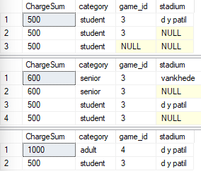

**Result and Discussion :**

Thus, we have implemented Construction of Cubes , OLAP Operations and OLAP Queries successfully.